Guide to Multi-class Image Classification :

* Refer collab note in AI/ML//Image Classification//MIT_indoor_classi_final.ipynb, Firstly we have to make sure the images are in correct format that is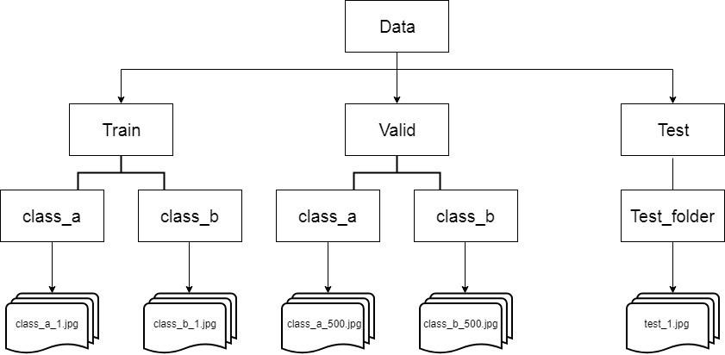
* Then we have to make sure we have only one type of images for example if jpeg then only jpeg and no other formats should be present. Then we should check that the image distribution is balanced in all the image class folders, if the distribution of images is not balanced then we need to apply data augmentation techniques to increase images in minority classes using ‘Data Augmentor’ and balance out the imbalanced classes or reduce the images in the majority classes.
* Next we should split the data in train, validation and test. Using ‘image_dataset_from_directory’ we can input the images in various batch and resize them to a specified dimension.
* To Choose the transfer learning model we can use a data driven approach and test with all the model to see which one would give us the best result with a small batch of the image data which we have.(small batch of data should be used for this step)
* After choosing the model we can use randomSearchCV to choose the hyper-parameters and fine tune to models hyper-parameters.
* After this we are ready to train the model, for training we can use a earlyStopping callback to monitor validation loss and patience of 3.
* For test we have to resize the test image to the same dimensions to which the training images were resized before training. We need to sort the class list and then get the predicted class.

Follow the colab link for better clarity: <https://colab.research.google.com/drive/1NoKgQ2J-s5lIIFYQL55JF2Tmp5xLQ5x5#scrollTo=HQagPmcBXIWT>

What are possible hyper parameters and their uses?

What is results are bad? what should be do?

val loss or val accuracy?